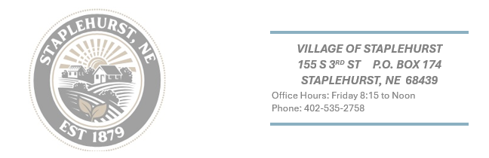
VILLAGE OF STAPLEHURST NOTICE OF SECIAL MEETING
NOTICE IS HEREBY GIVEN, that a meeting of the Chairperson and Council of the Village of Staplehurst, Nebraska, will be held at 7:00 P.M. on April 1st, 2025, hearing at the Village Hall, which meeting will be open to the public. An agenda for such meetings, kept continuously current, is available for public inspection at the office of the Village Hall. Except for items of an emergency nature, the agenda shall not be enlarged later than twenty-four hours before the scheduled commencement of the meeting.

- Call meeting to order and announce the Open Meeting Act.
- Roll Call
- Call to approve February Minutes
- Call to approve Village claims
- Call to approve Fire Dept. claims
- Fire Department Garage Door
- Call to approve plot extension at 805 A St.
- Call to change safe deposit box signers for Jones Bank
- Call to approve Policy/Procedures
- Call to approve Shred Day
- Adjourn

